Ad Hoc Persona
Brand: Atlas Packs

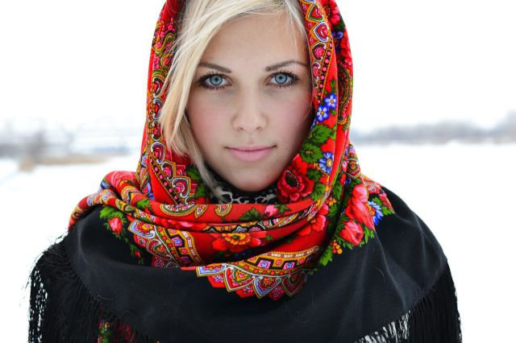

Name:
Sasha Dulka
Age:
27-years-old
Education:
MA Media Marketing
Quote:
“My love and passion are capturing the world around me in order to give myself a deeper perspective in my daily life and goals.”

Occupation:
Real Estate and Portrait Photographer
Income:
$70,000 - $90,000
User Environnent:
- Laptop, Tablet, Phone, Mirrorless DSLR Camera
- Works from home and outdoors
- Often collaborates with others but also works individually
- Works predominantly with Instagram, Facebook, and YouTube

Psychographics:
- Prefers remote hikes (easy/moderate for customers)
- Prefers quality over economy but also appreciates deals/discounts/sales
- Tends to stick with known brands
- Likes to use local small business restaurants or pubs for business meetings
- Usually likes to travel alone or with another person
- Every Friday will work out of a local café

End-Goals:
- Wants to continue to build strong community for her clients (SDT Relatedness)
- Desires to create a better work-life balance to reduce stress (SDT Autonomy)
- Wants to go out and explore trails more often to get away from her everyday hustle. (SDT competence and SET emotional/psychological states)
- Carrying around heavy equipment all the time hurts her back and makes her loose stamina. She needs to carry lighter gear. (SET mastery experience)
- Seeing fellow photographers on Instagram travel for work is what she desires. (SET vicarious experience and social persuasion)

Scenario:
“Every week I go out and explore remote places that I could also use for my clients. It is important to give them a mystic experience; one they will never forget. By capturing individuals, couples, or families amongst the forest, mountains, or riversides without other people to disrupt a session; gives my clients a sense of peace and prosperity. About a couple times a quarter I will do a long weekend backpacking venture with a friend, or even by myself, to gain clarity, peace, and knowledge about myself and the world around me. The biggest issue I have to overcome is keeping my gear dry from the weather and muscle fatigue due to the sheer weight of my gear.”

