Consumer Analysis
Item Purchased: Arc’teryx Down Jacket
Consumer Name: Becky H.

Nikki M. Wyss
Fielding Graduate University
Audience Engagement
Dr. Rutledge
October 9, 2021
About the Consumer
Becky is a photographer and outdoor enthusiast. Her social media feed is predominately photography, inspirational pages, and following outdoor equipment businesses (such as REI, Arc’teryx, etc.) She gained recognition of the brand through Instagram, not only through media ads, but through other photographers using Arc’teryx products and tagging them within their posts. She also moved to the U.S. from Canada so it is possible through the Instagram algorithm that the brand could have been recommended to her since Arc’teryx is a Canadian brand; but there is no data backing this opinion, so it is just an assumption.
Consumer Motivations
Her motivation relies very little on social or external gains; her motivators are based off quality, appearance (such as color variety), performance, reliability, utility, and how a particular product will help her reach her desired goals. When she isn’t working, she is out in nature to capture landscape and animals through photography, or she is backpacking and camping with her partner. Word-of-mouth recommendations from other photographers who have been in the industry longer than her matter more than marketing or media do. She typically doesn’t think spending a ton of money on an article of clothing is necessary but since other professionals’ opinions were nothing but positive and through comparing Arc’teryx to the quality of competitors; the recommendations made her feel more confident about the product which offset the cost.
Possible Cognitive Biases
Becky did her research but that doesn’t mean biases aren’t occurring. Since her partner had a similar jacket from Arc’teryx, she was inspired by other professionals, and cost was a commitment; the biases that come to mind are confirmation bias, anchoring bias, the bandwagon effect, mere exposure effect, the endowment effect, and the halo effect. As she had stated before she already had her eyes on this company even more so when she got immersed into their media feed; that’s where confirmation bias comes in. Even though she thought the price was too much initially she was relying on others feedback which were all confirmations to her existing idea about the brands quality and how it would perform. Anchoring bias may not have played a huge role in her decision making more so compared to other biases but seeing as her first source of information was based off her partner having one and seeing how it worked for him does play a role in her research. Since she talked about the recommendations of others who she has met through social media and through the photography network; the bandwagon effect has the biggest role within her purchasing decision especially since she got to see the product on multiple well-known photographers/adventurists both male and female. This is an important piece of information because, even though it may not have been the main concern for her, she was still wanting an article of clothing that looked good and had a variety of colors. The mere exposure effect (also known as the familiarity principle) falls into the same principle of the bandwagon effect due to media and acquaintance exposure to the brands products. The halo effect could be said to play a significant role due to the brands website. Arc’teryx website draws consumers in through their stunning imagery, mission statement, and presenting information as if the company was tailoring products just for them (consumers).
How Consumer Goals Align with Arc’teryx Mission Statement
Arc’teryx mission is to nurture connect with the purpose of enabling others to be “immersed in the moment of doing, regardless of external conditions.” (Arc’teryx Equipment, n.d.) One of Becky’s biggest problems in the past was having jackets that were too heavy and weren’t very packable. She needed a jacket that would be light weight, would keep her warm in extreme conditions, and would pack down to not take up a ton of space within her pack. This is exactly what Arc’teryx Equipment (n.d.) strives to provide “simple solutions to complex challenges; …[Having] the essence of minimalism [while]… reducing the effects of weather, streamlining use, and moving efficiently [creating a] timeless, outdoor experience.” What Arc’teryx stands for is perfectly in line with Becky’s goals of exploring the outdoors, staying warm, being minimal, and therefore increase her stamina to go farther distances.
How Self-Efficacy Theory Applies to Consumer Behavior
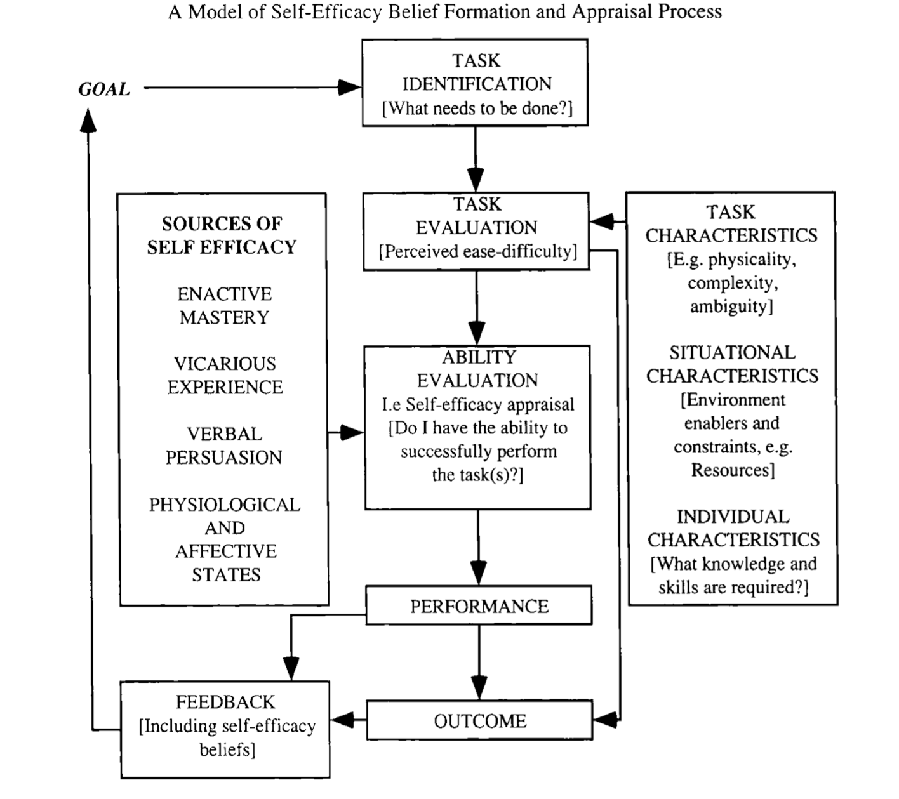
(Figure 1, Garlin, 2002)
Self-Efficacy explains how an individual’s perception of their capabilities can perform the actions necessary to achieve a desirable outcome to a given situation. (Garlin, 2002) Complex decision making (e.g. financial commitments, brand comparison, etc.) requires skillful performance in consumption (e.g. figuring out which product to purchase from what company and for what reasons) and/or arouse the need for self-regulatory skills that manage thoughts and feelings to cope with consumption activities (e.g. pulling the trigger on a new jacket because of a seasonal sale or going with a competitors jacket because a gift card was received to a competitive brand). (Garlin, 2002) Becky had a specific need and utility for her purchase to obtain a specific performance satisfaction in her activities and to increase her overall stamina. When shopping for products that can help obtain her goals, she is most likely going to be imagining herself in the product she is purchasing based off the information she has gained to try and visualize the use of the product in future endeavors.
Having a high performance of self-efficacy during the purchasing process can have a direct correlation to overall performance satisfaction on and off screen. One of the highest levels of attaining self-efficacy through Garlin’s research was performance attainment. This was shown in Becky’s extensive research to gain as much knowledge as she could about the brand and the specific product she was interested in purchasing. Leaning on the recollection of past performance was shown to not be a strong indicator of being able to take on future tasks such as brand evaluation and comparison. (Garlin, 2002) While Becky was obtaining knowledge about the jacket she wanted, the person she leaned on first for more information was her partner who had bought a men’s jacket from Arc’teryx. Media immersion from other professionals through her Instagram feed alongside her outreach to other photographers who had more experience to her are both examples of how vicarious experience played a significant part on persuading her purchasing decision. Word-of-mouth marketing is one of the most significant forms of marketing that business try to obtain which is why so many companies will spend hundreds of thousands if not millions on marketing through celebrities, public figures, or social media influencers because they bridge the gap between business and consumer trust and relationship. (See: “Importance of Implementing an eCommerce Business Strategy within SMEs”, Wyss, 2021)
Arc’teryx was the leading force behind verbal persuasion. Becky already had the backings of others she was close or acquainted with. When it came to ordering the jacket, she was presented with a website that encompassed everything she sees herself as and doing (personal assumption based off her attributes/characteristics and having understanding of the brands website layout, mission statement, and how it presents a personalized narrative). Knowing the brand is Canadian (she is proud about being from B.C. and will sometimes post pictures of cityscapes of B.C. saying how she misses that environment), having the brand mission be about nurturing community, praising their minimalistic features, and showing how with Arc’teryx products one can just do without worrying about the external environment; is exactly what she is looking for in the product she purchased. These statements that are given vibrancy through photos and videos embedded within the brands website could be a very easy persuasion to solidify self-efficacy and confidence she needed to go through with her purchase of the Arc’teryx Down Jacket instead of going with their competitor, Patagonia, even though she had a gift card from Patagonia and could have gotten the competitor jacket for free. Performance accomplishment, vicarious experience, and verbal persuasion all play a part in controlling her physiological state. She doesn’t like to make expensive purchases on clothing. Arc’teryx jackets price ranges from $250-$750; this is quite a financial commitment to an individual who is used to being frugal. Stress, anxiety, and lack of confidence with a product purchase are the main components that she had to overcome to gain a high level of self-efficacy. Having used the jacket in the field, she has no regrets about the purchase, recommends it to others, and is going to be a patron to the brand for future extreme weather products she or her partner may need.
Concluding Thoughts
Arc’teryx has a substantial social media presence, having almost 1 million followers and being verified through Instagram, while also utilizing the Instagram shop feature where followers/consumers can access the product they are interested in directly through the brands Instagram post; shows how essential social media plays to their marketing (opinion based off previous research). From the eyes of the brand, being able to conduct consumer interviews and build a theory-driven codebook to break down themes for a consumer behavior would be incredibly beneficial for creating personas to understand and utilize empathy and have a full understanding of the “why” behind consumers purchasing patterns and behaviors. Having the ability to understand target audiences as people instead of as data and understand the driving forces behind consumers mental processes and why they think the way they do is beneficial data for any company to produce quality narrative and persuasion within a brands marketing and media outlets.
Overall, Becky’s behaviors and beliefs I believe to be very representational to the brands target audience. Being a photographer and videographer myself, all equipment/products in the industry aren’t cheap. I go out of my way to obtain opinions and recommendations from those in the field as well when purchasing a product. I have had several other photographers ask for my own opinion on gear (which turned out to 3 sales for the same product, product cost is $400, based on my recommendations which were recognized by the company). In this industry marketing does play a role but not to the same extent as vicarious experience and verbal persuasion do.
All the questions asked within the interview seem to cover a lot of different aspects between goals, environment, social factors, financial commitment, etc. The only other question that might be beneficial would be to dive deeper into cultural roots; asking if there is a larger weight for choosing a Canadian company over an American one or one from any other country; depending on what the consumers answer is would define what questions would get asked thereafter.

References

Arc’teryx Equipment. (n.d.). Our Story | Arc’teryx. Retrieved October 10, 2021, from
https://arcteryx.com/ca/en/explore
Brooks, A. (2020, August 12). 9 Cognitive Biases That Influence Buyer Decisions. Venture
Harbour. https://www.ventureharbour.com/cognitive-biases-influence-buyer-decisions/
Dash, S., & Saji, K. B. (2008). The role of consumer self-efficacy and website social-presence in
customers' adoption of B2C online shopping: an empirical study in the Indian context. Journal of international consumer marketing, 20(2), 33-48.
Eccles, J. S., & Wigfield, A. (2002). Motivational beliefs, values, and goals. Annual review of
psychology, 53(1), 109-132.
Garlin, F. V., & McGuiggan, R. L. (2002). Exploring the sources of self-efficacy in consumer
behaviour. In 2002 Asia-Pacific ACR Conference. Association for Consumer Research.
Wyss, N. (2021, January 8). Nikki Wyss | Thesis Articles. Nikki Wyss.
https://www.nikkiwyss.com/thesis-proposals

